When the Easter Bunny Decided to Retire

As told to Grandpa Joe

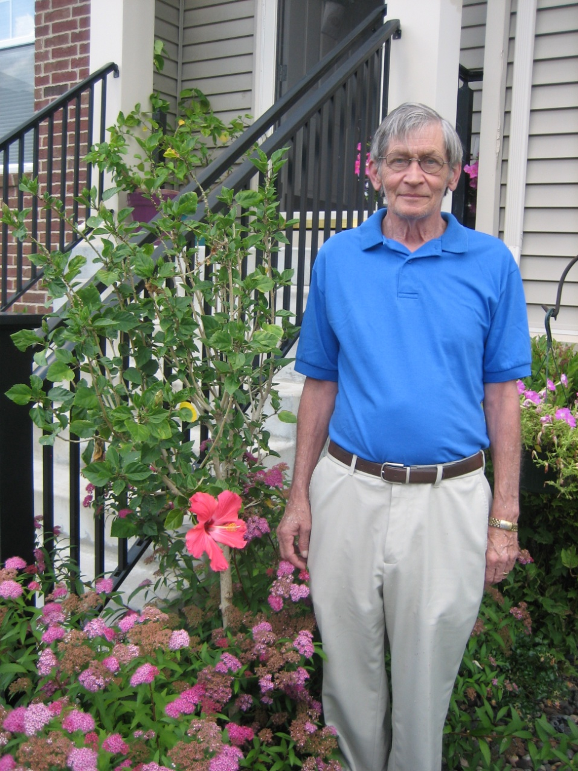

Change name and insert picture of giver of book

Copyright © 2016 Xanadu Inc. See Instructions on how to tailor this book to your child/children and permitted uses and copying.

**The Easter Bunny was very tired, nervous, and wired.**



And

**Every hour this made him quite sour.**

**Everyone wanted to keep in touch and it was just too much.**

**He had lost his leap**

**From lack of sleep.**

[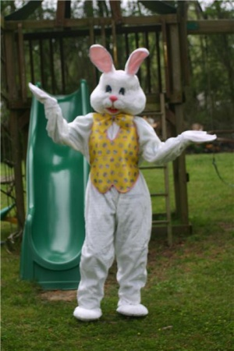](http://www.google.com/url?sa=i&rct=j&q=&esrc=s&source=images&cd=&cad=rja&uact=8&ved=0ahUKEwigrtm9qJjKAhVE5yYKHZZiCYsQjRwIBw&url=http://www.discovertechnology.com/kids-party-clowns-for-hire/Houston/Houston_Texas_Easter_Bunny_Costume_Character.htm&psig=AFQjCNH-vqtFRsuYCTpRa6zsd8mIAj4-yQ&ust=1452277205948564)

**Text and twitter.**

**It was enough to make him bitter. Without fail came cell calls and e-mail.**

[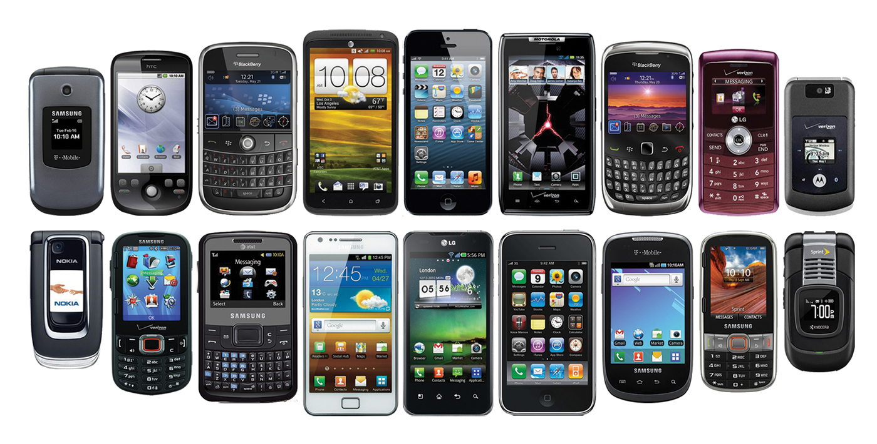](http://www.google.com/url?sa=i&rct=j&q=&esrc=s&source=images&cd=&cad=rja&uact=8&ved=0ahUKEwjos4jWt5jKAhXBPiYKHTDuBJAQjRwIBw&url=http://www.ywcancin.org/site/apps/nlnet/content2.aspx?c%3D6oJKL0PuF8JSG%26b%3D7960767%26ct%3D11606497%26notoc%3D1&bvm=bv.110151844,d.eWE&psig=AFQjCNEFjYp5RssQDF71l9-ddn9rKO1RkQ&ust=1452281320452310)

[](https://www.google.com/url?sa=i&rct=j&q=&esrc=s&source=images&cd=&cad=rja&uact=8&ved=0ahUKEwig_JKguZjKAhVC5SYKHYaOA3UQjRwIBw&url=https://www.facebookbrand.com/&psig=AFQjCNEeyzdOeOt6tCuUI5XGOLaCgQ0-Yg&ust=1452281749589110) 

**E-mail more and more**

**It became such a bore**

**All he could see**

**was technology.**

**It was not fine,**

**All this screen time.**

[](http://www.google.com/url?sa=i&rct=j&q=&esrc=s&source=images&cd=&cad=rja&uact=8&ved=0ahUKEwipxI2tytzKAhXITCYKHU-KCYkQjRwIBw&url=http%3A%2F%2Fwww.123rf.com%2Fphoto_4788597_computer-screen-with-internet-browser-with-pointers.html&psig=AFQjCNHURVQvwOQrlo1yZy7vuUB9GkjfVA&ust=1454622645742124)

**Not only that………..but**

**There were just so many eggs**

[](http://www.google.com/url?sa=i&rct=j&q=&esrc=s&source=images&cd=&cad=rja&uact=8&ved=0ahUKEwi_qvDStpjKAhVHKCYKHTEGAVAQjRwIBw&url=http://rcha4u.org/robbins-annual-easter-egg-hunt/&psig=AFQjCNH-vqtFRsuYCTpRa6zsd8mIAj4-yQ&ust=1452277205948564)

**And so many pips and chocolate rolls!!!**

[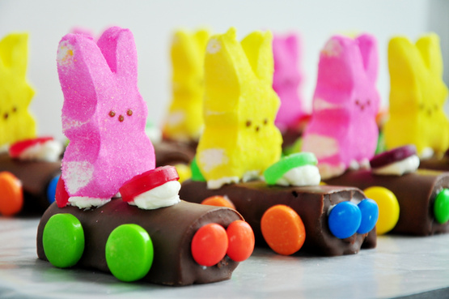](http://www.google.com/url?sa=i&rct=j&q=&esrc=s&source=images&cd=&cad=rja&uact=8&ved=0ahUKEwi9147ytZjKAhXIMSYKHecPD5YQjRwIBw&url=http://www.great-kids-birthday-parties.com/easter-printables.html&psig=AFQjCNH-vqtFRsuYCTpRa6zsd8mIAj4-yQ&ust=1452277205948564)

**It wasn’t fair.**

**There was no rest for this hare.**

**He was in a stew**

**Wondering what to do.**



To Lulu”s school in St Louis Park

the bunny went

Maybe the teachers would have a hint.

[](http://www.google.com/url?sa=i&rct=j&q=&esrc=s&source=images&cd=&cad=rja&uact=8&ved=0ahUKEwjOkciq3KnKAhVB5yYKHQS1CjMQjRwIBw&url=http://publicschools.manchesterct.gov/page.cfm?p%3D1220&psig=AFQjCNGzE1JRKRa4MSrn7xWP3M6olWqPlQ&ust=1452875272496469)

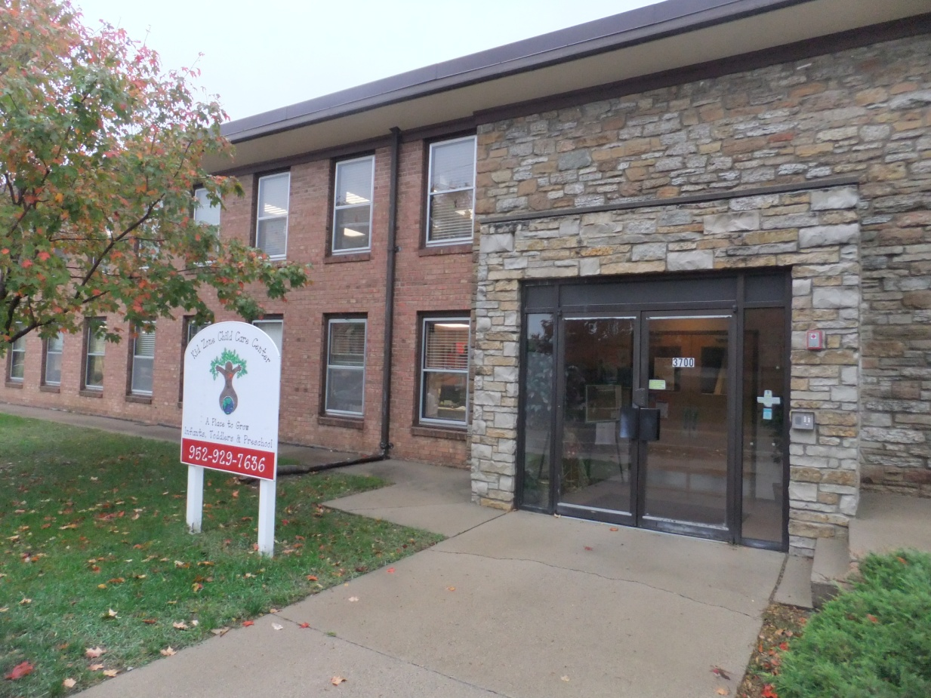

Change text and Insert picture of child’s school and delete cartoon school or delete photo and expand cartoon,

One teacher said “Move to Disney Land.”

Great idea other teachers said

We will give you a hand.





**Another teacher said why not rest to the max???**

**You can retire and relax.**

Bunny thought

“I could be free

of Easter baskets and candy.”

[](http://www.google.com/url?sa=i&rct=j&q=&esrc=s&source=images&cd=&cad=rja&uact=8&ved=0ahUKEwjY6LD-oMXKAhVmuYMKHXrEDg4QjRwIBw&url=http%3A%2F%2Fwww.techmanos.com%2Fshare%2520_your_dreams.htm&psig=AFQjCNGMMifrVq26Rmwm3pPhCdf2KZr6mA&ust=1453821424383492)

**“Right up there on my list is fun**

**I would have time for hop scotch, ihop, and playing in the sun.”**



[](http://www.google.com/url?sa=i&rct=j&q=&esrc=s&source=images&cd=&cad=rja&uact=8&ved=0ahUKEwi45YvWiaLKAhXCYyYKHbM1DGMQjRwIBw&url=http://7-themes.com/7016046-sunny-beach-wallpaper.html&psig=AFQjCNFY1oZTeLy8QrFwxLZqJVuUmWqRaw&ust=1452612570784727)

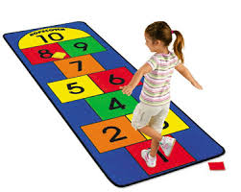

**I’ll call the mad Hatter**

**He knows about where to go and**

**things that matter.**

“No trip to the big city or the highlands. You can retire to the

Easter Islands.”

[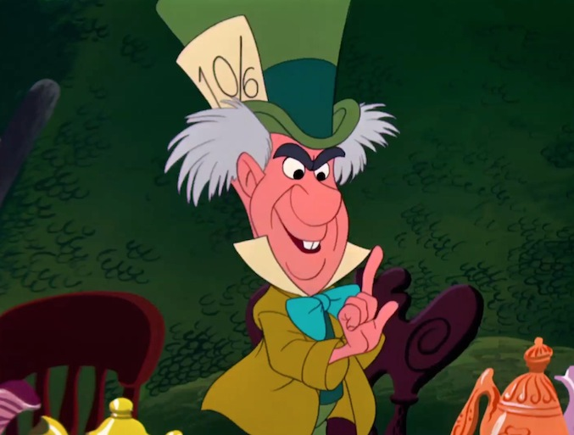](http://www.google.com/url?sa=i&rct=j&q=&esrc=s&source=images&cd=&cad=rja&uact=8&ved=0ahUKEwiY5IWD_ZrKAhXLJCYKHaE1Di0QjRwIBw&url=http://blogs.disney.com/oh-my-disney/2013/05/27/eligible-disney-bachelors/attachment/bachelor-mad-hatter/&psig=AFQjCNGb7BLzc5-Kdr6K8AkRmPzouyGczg&ust=1452368545289053)

**He pointed to a dot.**

**“That’s where we go, that’s our spot!**

**I can arrange to see statutes so strange.**

**And you can bet**

**there’s a beautiful sunset.**

**To be sure**

**a wonderful adventure.**

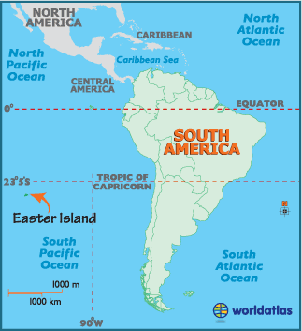

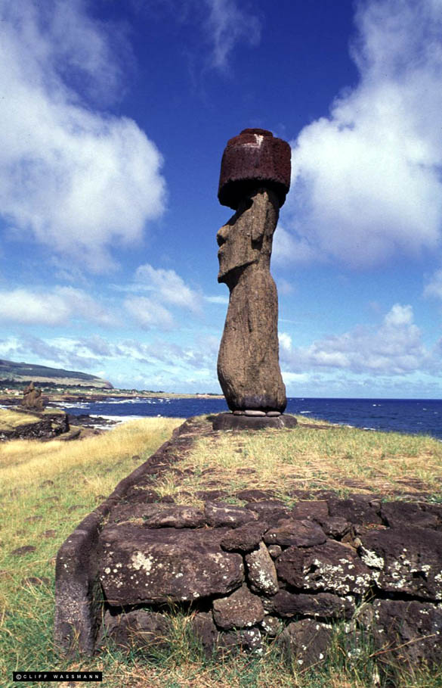

[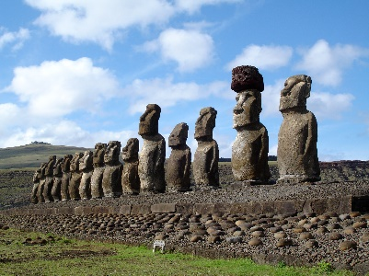](https://www.google.com/url?sa=i&rct=j&q=&esrc=s&source=images&cd=&cad=rja&uact=8&ved=0ahUKEwih9qynhaLKAhUBUD4KHd_GBQoQjRwIBw&url=https://www.reddit.com/r/pics/comments/2xgkah/full_unearthed_statue_of_easter_island_head&psig=AFQjCNFX4nOzJ8yNQ8qtWSU8x7OC4rX92A&ust=1452611403276158)

[](http://www.google.com/url?sa=i&rct=j&q=&esrc=s&source=images&cd=&cad=rja&uact=8&ved=0ahUKEwjgjfWFhqLKAhWB7iYKHafIAiYQjRwIBw&url=http://experiencesouthamerica.com/holiday/experience-easter-island/&psig=AFQjCNFX4nOzJ8yNQ8qtWSU8x7OC4rX92A&ust=1452611403276158)

“Without fail

We’ll have a sail

When we land

we’ll play in the sand.

No more bringing eggs and candy.

I will retire to someplace warm and sandy.

Instead of giving candy to the girls and boys

I’ll have lots of time to play with my toys.”





**with**

Even Bugs thought moving had merit as long as he could grow a carrot.

[](http://looneytunes.wikia.com/wiki/Bugs_Bunny/Gallery)

[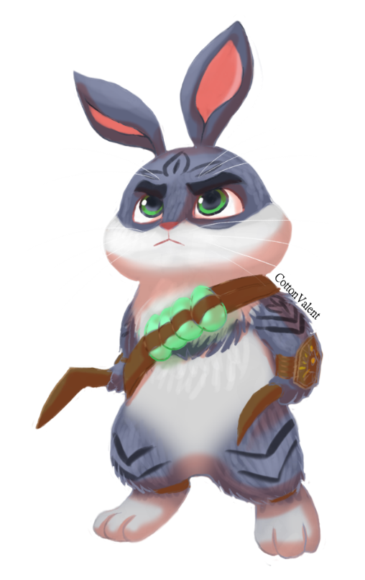](http://www.google.com/url?sa=i&rct=j&q=&esrc=s&source=images&cd=&cad=rja&uact=8&ved=0ahUKEwjPkoGOtpjKAhVM6SYKHR0sAlMQjRwIBw&url=http://cottonvalent.deviantart.com/art/Bunny-in-otome-game-342945374&psig=AFQjCNH-vqtFRsuYCTpRa6zsd8mIAj4-yQ&ust=1452277205948564)

Grumpy rabbit wasn’t so sure moving to these islands was the cure.

“I’m sorry to say

We may need to cancel the holiday.”

**Other bunnies said “please don’t say**

**No chocolate, no eggs or peeps**

**And the baskets put away.”**

[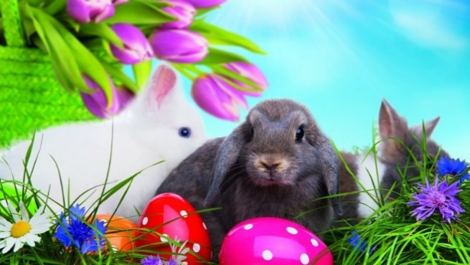](http://www.google.com/url?sa=i&rct=j&q=&esrc=s&source=images&cd=&cad=rja&uact=8&ved=0ahUKEwjPpP7XtZjKAhVB5yYKHfpRBG0QjRwIBw&url=http://wallpaperfx.com/holidays&psig=AFQjCNH-vqtFRsuYCTpRa6zsd8mIAj4-yQ&ust=1452277205948564)



**When she heard the news at last**

**Tinkerbell was worried and agast.**

[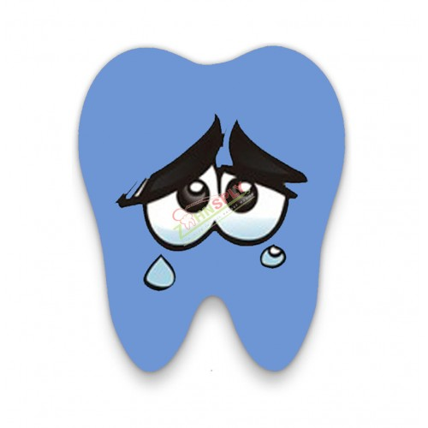](http://www.google.com/url?sa=i&rct=j&q=&esrc=s&source=images&cd=&cad=rja&uact=8&ved=0ahUKEwjZ5cDB1KnKAhXB6CYKHVN0AhsQjRwIBw&url=http://zahnsply.com/crying-in-pain-tooth-emoji-dental-acrylic-key-chain.html&psig=AFQjCNHVPPpXW226i7QdrGYh2Sg81wxi0A&ust=1452872991896818)

**Tooth was full of fear and shed a tear.**

**“Cancel Easter what a thought.**

**No gifts to give the children will be distraught.”**



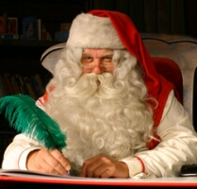

On hearing the news Santa said “Oh me, oh my.

All the children will cry.”

**And cry they did!!!**

[](http://www.google.com/url?sa=i&rct=j&q=&esrc=s&source=images&cd=&cad=rja&uact=8&ved=0ahUKEwj528WY_cXKAhUD2T4KHW0zDT8QjRwIBw&url=http%3A%2F%2Fwww.todaysparent.com%2Ftoddler%2Ftoddlers-stop-fake-crying%2F&psig=AFQjCNFWnSsh4lBYN_9oYHLKL5VHZU3mDw&ust=1453845980012448)[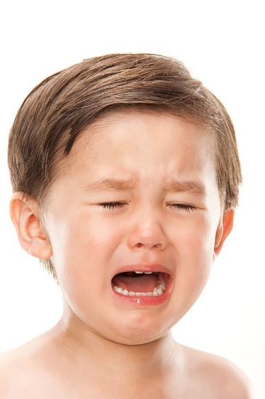](http://www.google.com/url?sa=i&rct=j&q=&esrc=s&source=images&cd=&cad=rja&uact=8&ved=0ahUKEwipgM3C_cXKAhXCcT4KHQXyC0kQjRwIBw&url=http%3A%2F%2Fwww.mirror.co.uk%2Fnews%2Fworld-news%2Fparents-hand-out-earplugs-fellow-4848179&psig=AFQjCNFWnSsh4lBYN_9oYHLKL5VHZU3mDw&ust=1453845980012448)

[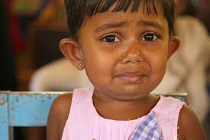](https://www.google.com/imgres?imgurl=https://c2.staticflickr.com/4/3059/3486673053_487a5191f5_z.jpg%253Fzz%253D1&imgrefurl=https://www.flickr.com/photos/worldbank/3486673053&h=427&w=640&tbnid=kvlUaSLYzNcpnM:&docid=dvZiaL109z5f1M&ei=HJ2mVtSoKcjB-wGS96zYBA&tbm=isch&ved=0ahUKEwjUptuW_cXKAhXI4D4KHZI7C0s4rAIQMwgdKBowGg)

[](https://www.google.com/imgres?imgurl=http://4.bp.blogspot.com/-_Luwyukemvs/U5XssQ42ZRI/AAAAAAAAIOE/FQzycJu-4xY/s1600/wailing-smiley.png&imgrefurl=http://www.symbols-n-emoticons.com/2013/02/wailing-and-crying-smiley.html&h=500&w=500&tbnid=3e_ko71Bl7sStM:&docid=a4TNSgwhcd3aMM&ei=n8OXVouWJcTymQHM6a7ICA&tbm=isch&ved=0ahUKEwjL4ejl06nKAhVEeSYKHcy0C4kQMwhHKBEwEQ)

[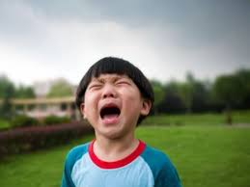](https://www.google.com/imgres?imgurl=http://you.co.za/wp-content/uploads/2015/02/child-crying.jpg&imgrefurl=http://you.co.za/supermom/help-my-child-doesnt-want-to-go-to-school/&h=450&w=600&tbnid=4mujphJPijHYsM:&docid=lJ9zeWBQtgMwtM&ei=juOvVunYJ-a4jgSi-oKoBQ&tbm=isch&ved=0ahUKEwjp1_3P1dfKAhVmnIMKHSK9AFU4yAEQMwgcKBkwGQ)



**Lulu and more than one classmate**

**Didn’t want the treats cancelled or even late.**

**She likes looking high and wide**

**For treats outdoors and inside.**

**Lulu**

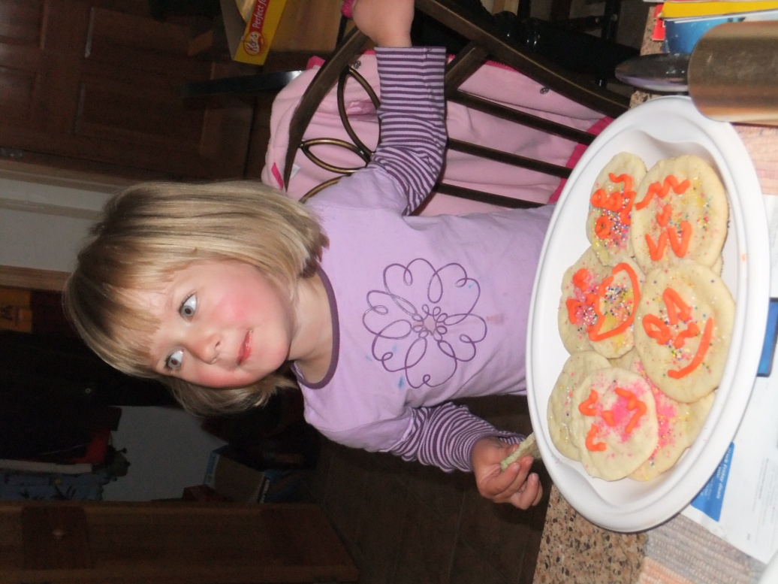

***“And it would be slick***

***To pet a bunny or a chick.”***

Change name and insert picture.

[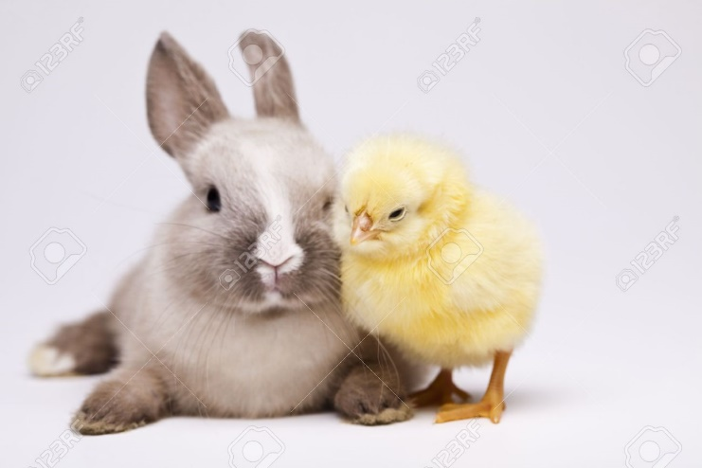](http://www.google.com/url?sa=i&rct=j&q=&esrc=s&source=images&cd=&cad=rja&uact=8&ved=0ahUKEwiikYigt5jKAhXB4CYKHQ-ZC5gQjRwIBw&url=http://www.123rf.com/photo_9118565_easter-bunny-on-chick-white-background.html&psig=AFQjCNH-vqtFRsuYCTpRa6zsd8mIAj4-yQ&ust=1452277205948564)

Grumpy Bunny said “There must be something new we can do

Without Easter Bunny all the children I have met will be upset .”

[](http://www.google.com/url?sa=i&rct=j&q=&esrc=s&source=images&cd=&cad=rja&uact=8&ved=0ahUKEwjPkoGOtpjKAhVM6SYKHR0sAlMQjRwIBw&url=http://cottonvalent.deviantart.com/art/Bunny-in-otome-game-342945374&psig=AFQjCNH-vqtFRsuYCTpRa6zsd8mIAj4-yQ&ust=1452277205948564)

**“This is not funny,” said magic bunny**



**“We can’t fail, someone must help with the e-mail.**

**He can’t be the one all alone to answer the telephone.**

**Millions of bunniess can use their legs**

**to help deliver Easter eggs.”**

E

**With his magic wand**



**he sent out the command**

**Millions and millions came**

**from near and far**

**Some hopping and by bus and car.**

[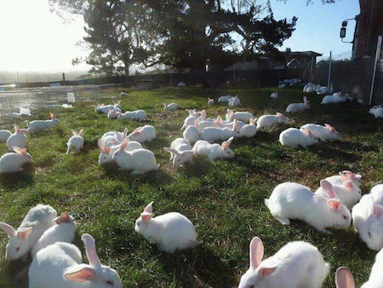](http://www.google.com/url?sa=i&rct=j&q=&esrc=s&source=images&cd=&cad=rja&uact=8&ved=0ahUKEwjg_Za688zKAhXivYMKHdIpBzIQjRwIBw&url=http%3A%2F%2Fwww.animalsaustralia.org%2Ffeatures%2Frabbit-rescue.php&psig=AFQjCNHMiBHqPtUFqF81qUw5wKLNKnrTfQ&ust=1454084017385792)

**They arrived black and white. It was quite a sight.**

**Big and small some with tails some none at all.**

**One kind of fat and another in a party hat.**

[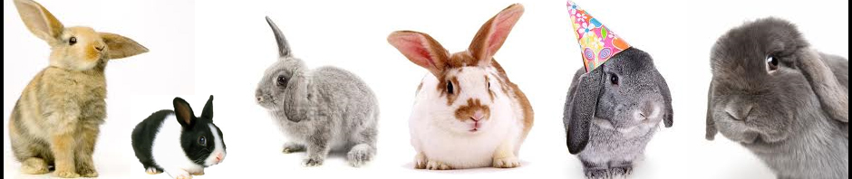](http://www.google.com/url?sa=i&rct=j&q=&esrc=s&source=images&cd=&cad=rja&uact=8&ved=0ahUKEwjgntiL9MzKAhVslYMKHRogBrUQjRwIBw&url=http%3A%2F%2Fwww.rabbit.tamilnadufarms.com%2F&psig=AFQjCNHMiBHqPtUFqF81qUw5wKLNKnrTfQ&ust=1454084017385792)

**There was a giant mob**

**All ready to help with the job**

[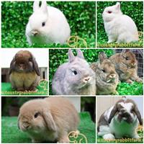](http://www.google.com/url?sa=i&rct=j&q=&esrc=s&source=images&cd=&cad=rja&uact=8&ved=0ahUKEwi_u9Tc9MzKAhUisoMKHW4vDKsQjRwIBw&url=http%3A%2F%2Fwww.weiku.com%2FAnimal-Products%2Fbuy-rabbit-farm.html&psig=AFQjCNHMiBHqPtUFqF81qUw5wKLNKnrTfQ&ust=1454084017385792)

[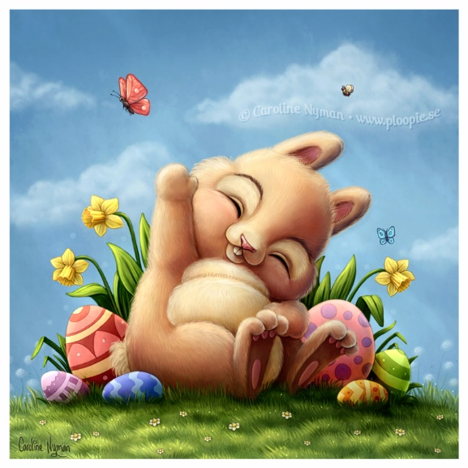](http://www.google.com/url?sa=i&rct=j&q=&esrc=s&source=images&cd=&cad=rja&uact=8&ved=0ahUKEwiQiPqUqJjKAhVK6SYKHfKyBWYQjRwIBw&url=http://www.ploopie.se/a-little-easter-bunny&psig=AFQjCNHBld68WSw2QSCqvIeTuduA7y5pkw&ust=1452277110777189)

And Easter Bunny clapped his hands and said,

“I will not retire, Easter is coming, full steam ahead.”

And there were smiles for miles

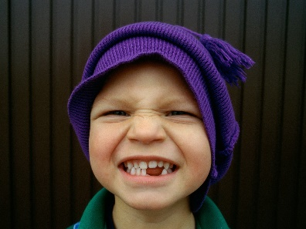

**If the truth be told**

**A smile never gets old**



Insert Picture Hopefully smiling

**Easter Bunny added**

**“It may sound sappy**

**but color me happy.”**

[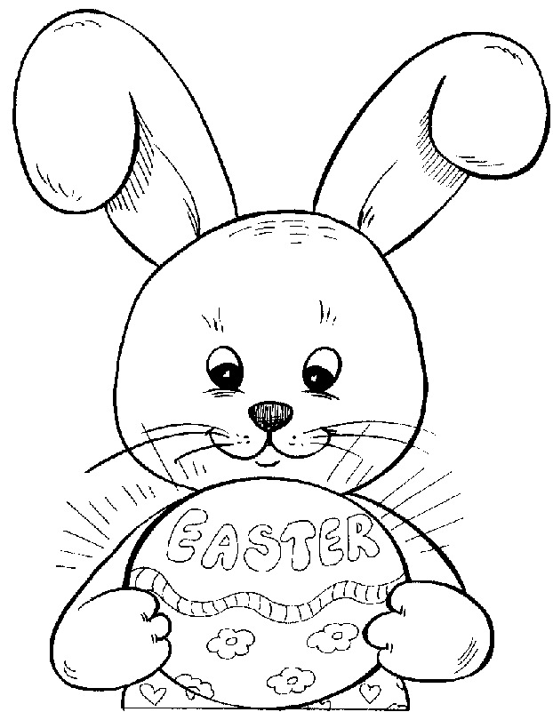](https://www.google.com/url?sa=i&rct=j&q=&esrc=s&source=images&cd=&cad=rja&uact=8&ved=0ahUKEwia1NOHzs3KAhVFFh4KHSnfC3IQjRwIBw&url=https%3A%2F%2Fwww.pinterest.com%2Fpin%2F331577591288044019%2F&psig=AFQjCNEatC1-uFJlDG1zd1jVTVgyIU0oQw&ust=1454108325502824)

When the people did learn

Of the Easter Bunny’s return

The crowd was very loud.

[](https://www.google.com/url?sa=i&rct=j&q=&esrc=s&source=images&cd=&cad=rja&uact=8&ved=0ahUKEwij28Dqy83KAhWDPB4KHV0YBCYQjRwIBw&url=https%3A%2F%2Fopenreflections.wordpress.com%2F2011%2F08%2F03%2Fon-crowd-funding-open-access-scholarly-books%2F&psig=AFQjCNEkFNf9IK50YqXh7xhqfuw-vG2w0g&ust=1454107773574677)

It wasn’t weird when some of Lulu’s family cheered.

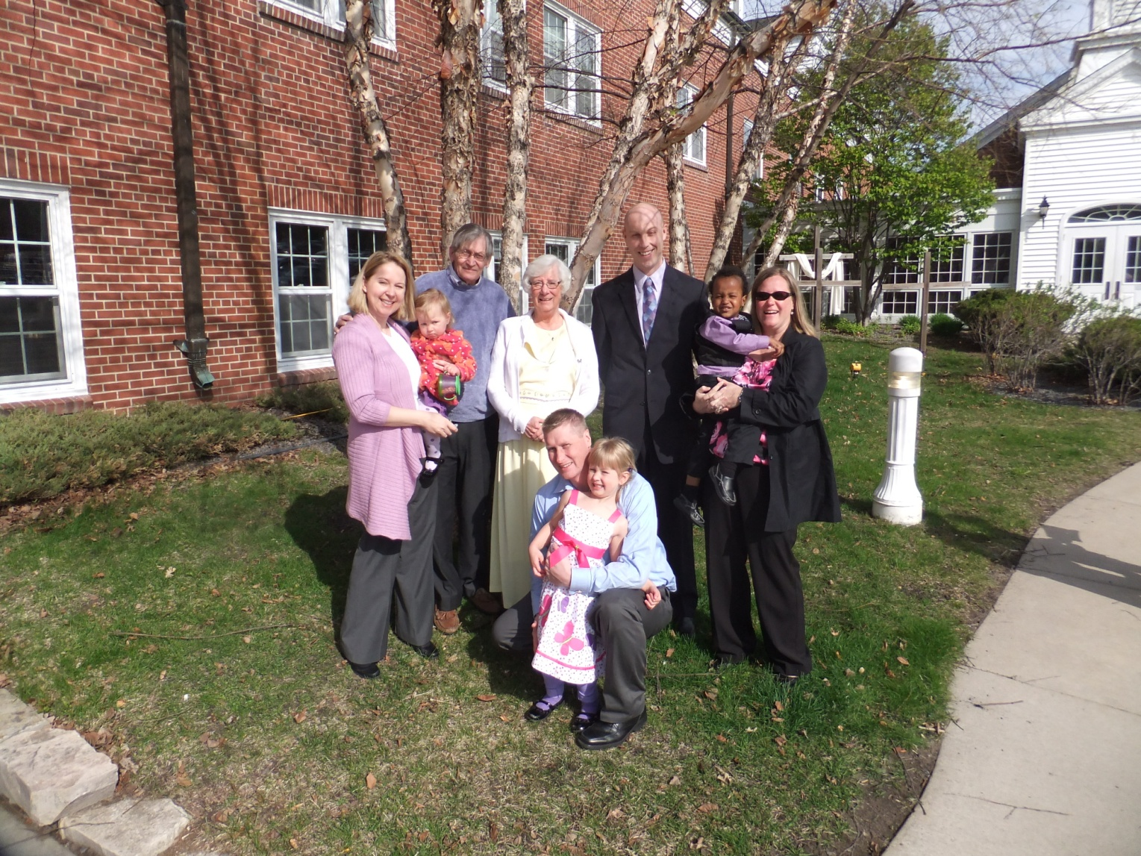

**Change name and insert family picture. Additional pictures can be added below,**